**DevOps Doc**

Architecture DevOps

---น่าจะถูกแล้ว---

Screenshots of docker container lists

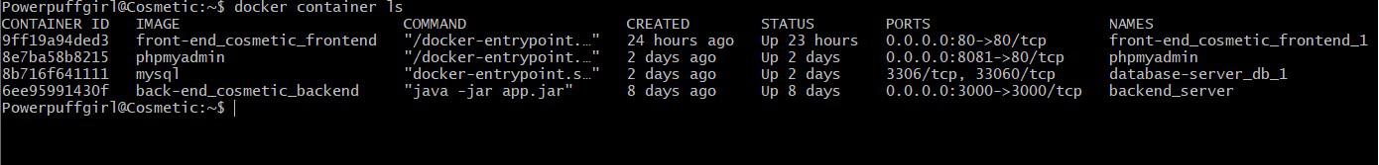

In the same bridge network has 4 containers but main containers including Front-end,Back-end,mysql (database) and another one is reverse proxy

docker-compose file of reverse proxy

define path to link to each container in nginx.conf file

Dockerfile of Front-end

docker-compose file of Front-end

Dockerfile of Back-end

Docker-compose of Back-end

Defined the environment in .bashrc file

Docker-compose of database

